WEBSITE DEPARTMENT DETAILS FORMAT
About the Department
1. The Visual Communication Department was founded with the aim of fostering excellence in creative and media education. It has grown into a vibrant space where artistic expression meets academic and professional advancement.
2. Our programs are thoughtfully crafted to keep pace with the latest developments in media, design, and digital platforms. We equip students with the skills needed to thrive as imaginative and industry-ready visual communicators.
3.Our teaching team is made up of experienced educators and professionals from the media and creative industries, all dedicated to guiding students toward their full potential.
4. Emphasizing a student-focused learning environment, we provide hands-on experience in areas like photography, filmmaking, animation, graphic design, and advertising. This is further enhanced through project-based learning and internship opportunities.
5. We also maintain strong partnerships with production houses, studios, and creative agencies, giving students valuable exposure to industry practices, innovation, and collaborative learning.
Vision (Department)
- To be a pioneering department in Visual Communication, cultivating a culture of creative excellence and empowering students to become leaders in the global media and design industry.
- To foster a vibrant academic environment that blends artistic expression with technology, preparing students to craft impactful visual narratives that inspire and inform society.
Mission (Department)
- To deliver quality education in visual communication by combining creative skills, technical knowledge, and ethical values.
- We aim to nurture talented professionals through hands-on training, research, and industry exposure.
- To empower students with the ability to think visually, communicate effectively, and innovate across media platforms. Our mission is to bridge academics with industry needs through experiential learning and creative exploration.

Programmes Offered
Certificate Courses
1. Digital Photography
2. Graphic Designing

Industry-oriented Skill Programs
1. Short film making
2. Video Editing

Goal
Short term goal
1. To strengthen practical training through workshops and hands-on sessions in photography, video production, and graphic design.
2. To organize guest lectures and seminars with media professionals and industry experts.
3. To enhance student participation in short film contests, design exhibitions, and creative competitions.
4. To upgrade lab infrastructure and software tools to meet current industry standards.
5. To encourage students to undertake internships with reputed media houses and design studios for real-time experience.

Long Term Goal
1. To establish the department as a recognized centre for excellence in media education, research, and creative innovation.
2. To build strong industry-academic partnerships for collaborative projects, placements, and curriculum development.
3. To introduce advanced diploma and postgraduate programs in specialized areas like animation, film production, and digital media.
4. To create a vibrant alumni network that supports mentoring, internships, and career opportunities for students.
5. To publish student-led media content such as short films, design portfolios, and digital magazines on national and international platforms.

Program Outcomes (POS)
PO 1: Conceptualize the basic concepts, applied techniques and advanced applications of visual communication and also update its developments
PO 2: Contribute skills for effective representation of issues, challenges and solutions in media
PO 3: Communicate the ideas, experiences and expectations in vernacular language, communicative language and visual forms in this media centered community
Program Specific Outcomes (POS)
PSO 1: employ creativity individually or collectively in media centered careers and execute action research in techno savvy and eco -friendly approaches in media
PSO 2: explore, educate and equip themselves in this media centered century
PSO 3: become ethically committed media professionals and entrepreneurs adhering to the human values
MoUs Signed
- International Global Film Festival,Chennai.
Toppers (Font: Verdana, Size: 10)
Batch Toppers (2020-2023)- First 3 Places
1. M. Sri Saisutharsana
2.S.Vignesh
3. G.Gokulavanan
Achievement
Each award section will include:

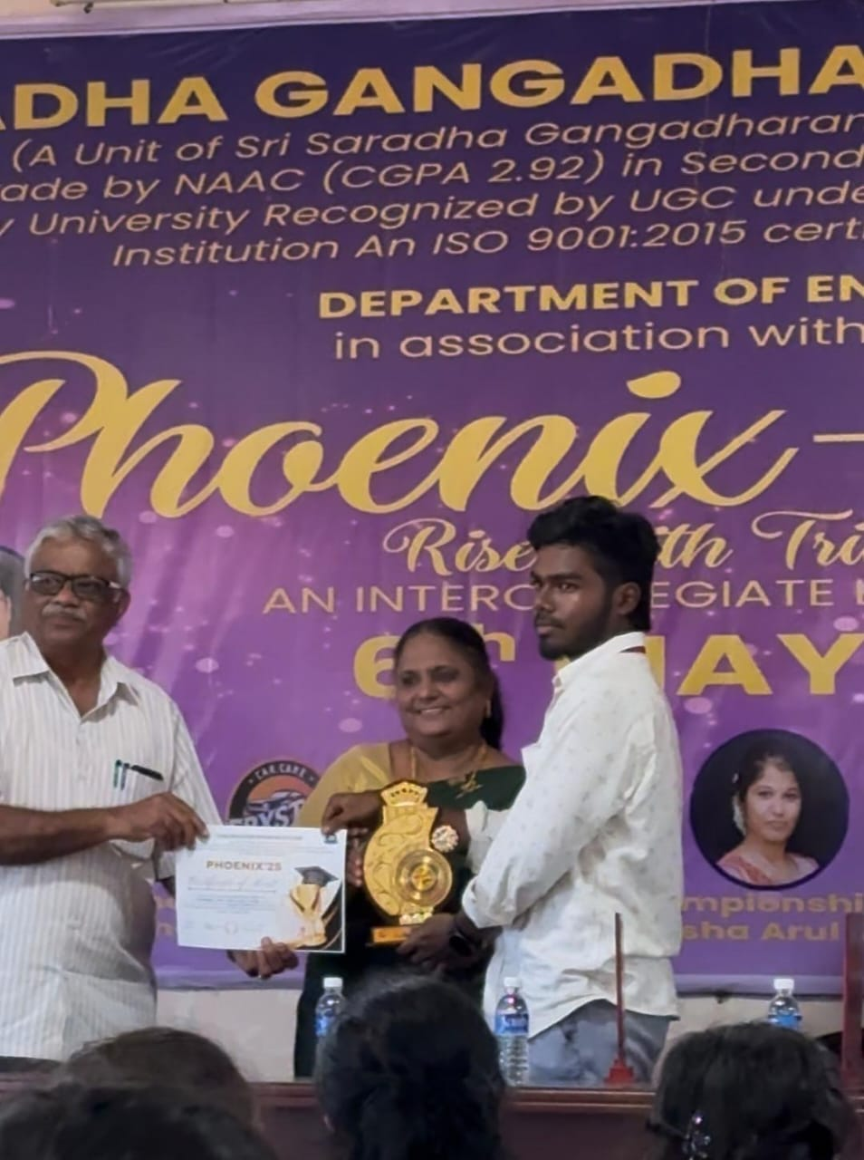
Prize: I Place
Level: State
Event: Phoenix- Mobile Photography Competition
Year: 2025

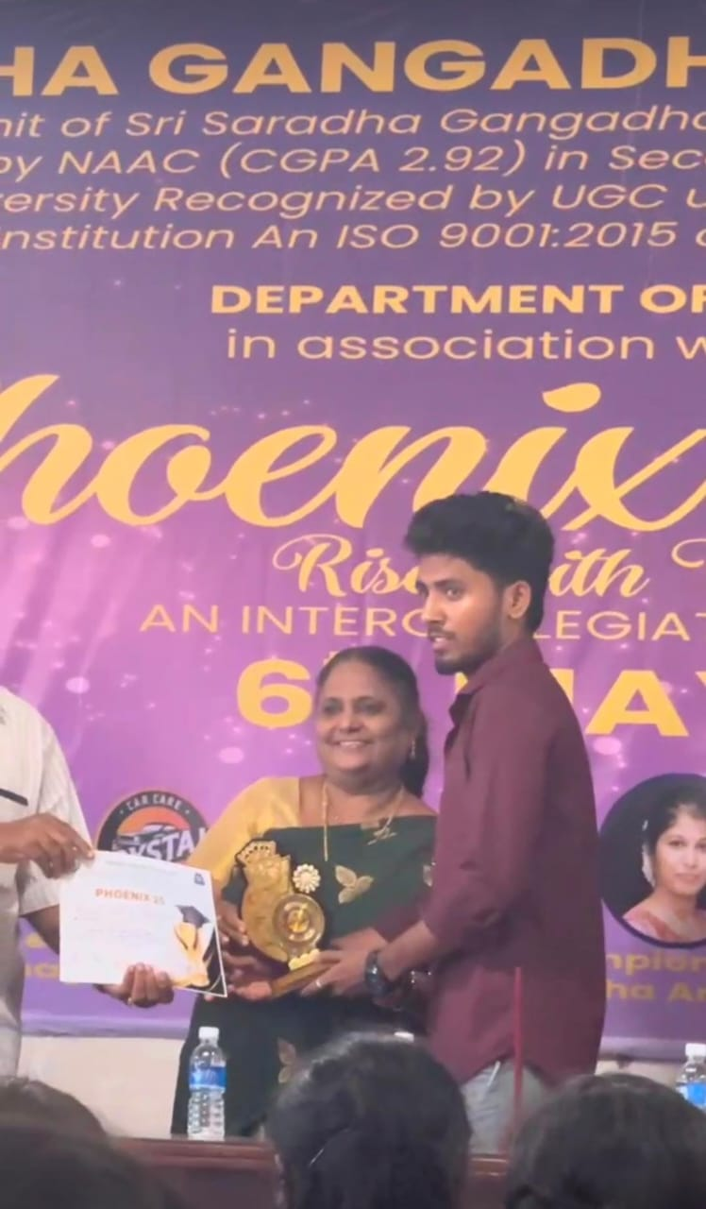

Prize: II Place
Level: State
Event: Phoenix- Mobile Photography Competition
Year: 2025

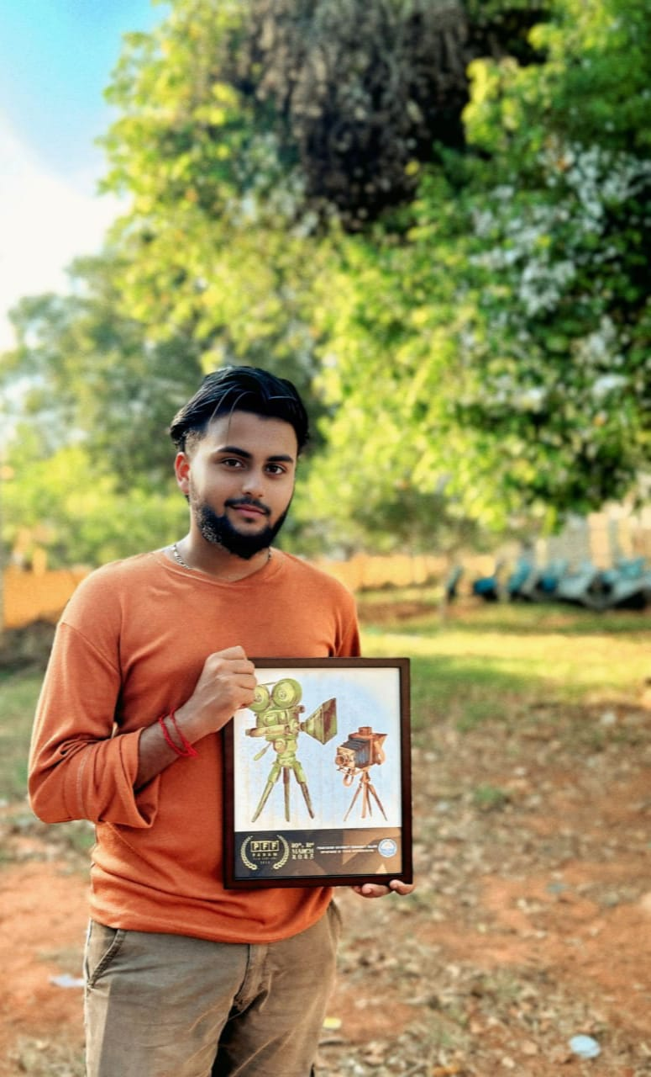
Prize: Best Shot Film
Level: National
Event: Phoenix- Padam Film Festival
Year: 2025

